STATISTICAL MODELING & HYPOTHESIS TESTING REPORT
Hotel Booking Cancellations
A Logistic Regression Analysis of Predictors and Statistical Significance

Dataset: hotel_bookings_cleaned.csv • 87,203 bookings • 36 fields
Method: scikit-learn Logistic Regression + statsmodels Logit (statistical inference)
Prepared: August 2026

1. Executive Summary
This report analyzes booking-level data from a hotel reservations dataset to understand and predict guest cancellations. A logistic regression model was built using seven booking-related features, and a formal statistical hypothesis test was performed to determine whether these features have a statistically significant relationship with the likelihood of cancellation.
The dataset contains 87,203 bookings, of which 24,008 (27.5%) were cancelled. The predictive model achieved an overall accuracy of 72.8% and a ROC-AUC of 0.668 on held-out test data. More importantly, the statistical inference model found that all seven features were statistically significant predictors of cancellation (p < 0.05 in every case), leading to a clear rejection of the null hypothesis: booking behavior variables such as lead time, price, party size, length of stay, prior cancellation history, booking changes, and waiting-list time are genuinely associated with whether a guest cancels.
While the model is statistically significant, its practical predictive power for identifying cancellations specifically is modest (recall of only 11% for the cancelled class), indicating it is better suited to explaining which factors matter than to serving as a stand-alone early-warning system in its current form. Recommendations for improving predictive performance are discussed in Section 7.

2. Introduction & Business Problem
Booking cancellations are a persistent challenge for hotels: they create uncertainty in demand forecasting, revenue management, and staffing. Understanding what drives a guest to cancel — and whether that relationship is statistically reliable rather than coincidental — allows a hotel to design targeted interventions (e.g., deposit policies, reminder communications, or overbooking strategies).
This analysis uses a cleaned dataset of hotel bookings spanning two hotel types (City Hotel and Resort Hotel) to (1) build a predictive model of cancellation and (2) formally test whether a set of booking-behavior features has a statistically significant effect on cancellation probability.

3. Hypothesis
The analysis is framed as a formal statistical hypothesis test on the coefficients of a logistic regression model predicting is_canceled (1 = cancelled, 0 = not cancelled):
Null Hypothesis (H₀) | The selected features have no effect on the log-odds of a booking being cancelled (i.e., each feature's coefficient equals zero).
Alternative Hypothesis (H₁) | At least one selected feature has a statistically significant effect on the log-odds of cancellation (its coefficient is not equal to zero).
Significance Level (α) | 0.05 — a feature is deemed statistically significant if its p-value is below this threshold.
Each of the seven features is also tested individually, allowing the hypothesis to be evaluated both at the overall model level and per-feature level.

4. Methodology

4.1 Dataset Overview
The dataset hotel_bookings_cleaned.csv contains 87,203 bookings across 36 columns, covering two properties — City Hotel (53,272 bookings) and Resort Hotel (33,931 bookings). The target variable, is_canceled, is binary: 63,195 bookings (72.5%) were not cancelled, and 24,008 (27.5%) were cancelled. No missing values were found in any of the modeling features.

4.2 Feature Selection
Seven predictors were selected to capture different dimensions of booking behavior — how far in advance the booking was made, its price, its size, its duration, and the guest's history with the hotel:
Feature | Description
lead_time | Days between the booking date and the arrival date
adr | Average Daily Rate — price paid per night
total_guests | Total number of guests on the booking
total_nights | Total nights stayed (weekend + weekday nights)
previous_cancellations | Number of the guest's prior bookings that were cancelled
booking_changes | Number of amendments made to the booking after creation
days_in_waiting_list | Days the booking spent on a waiting list before confirmation

4.3 Data Quality & Multicollinearity Checks
Before modeling, the selected features were checked for missing values (none were found) and for multicollinearity using the Variance Inflation Factor (VIF). A VIF near 1 indicates negligible correlation with other predictors; values above 10 typically warrant concern.
Feature | VIF
lead_time | 2.30
adr | 5.78
total_guests | 6.65
total_nights | 3.35
previous_cancellations | 1.00
booking_changes | 1.14
days_in_waiting_list | 1.03
All VIF values fall well below the conventional concern threshold of 10, confirming that multicollinearity is not a material issue for this feature set.

4.4 Train / Test Split
The data was split into an 80% training set and a 20% test set (random_state = 42 for reproducibility), so the model could be evaluated on bookings it had not seen during training.

4.5 Modeling Approach
Two complementary models were built on the same features:
- Predictive model — scikit-learn Logistic Regression: trained on the 80% training split to generate class predictions and cancellation probabilities on the test set, used to evaluate real-world predictive performance.
- Inferential model — statsmodels Logit: fit on the full feature set with an intercept term, used specifically to obtain coefficients, standard errors, and p-values for formal hypothesis testing.

5. Results

5.1 Predictive Performance
On the 17,441-booking test set, the model achieved:
Metric | Value
Accuracy | 72.80%
ROC-AUC | 0.668

Confusion Matrix
The confusion matrix below shows how predictions compared to actual outcomes on the test set:
 | Predicted: Not Cancelled | Predicted: Cancelled
Actual: Not Cancelled | 12,184 | 432
Actual: Cancelled | 4,312 | 513
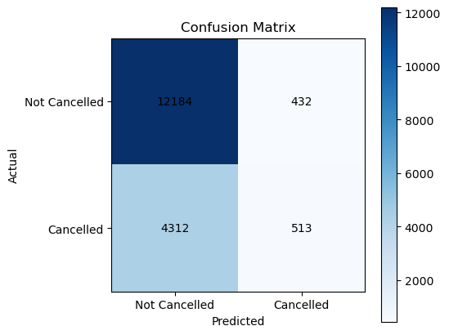
Figure 1. Confusion matrix heatmap — darker cells indicate a higher count of bookings.

Classification Report
Class | Precision | Recall | F1-score | Support
0 (Not Cancelled) | 0.74 | 0.97 | 0.84 | 12,616
1 (Cancelled) | 0.54 | 0.11 | 0.18 | 4,825
Accuracy |  |  | 0.73 | 17,441
Macro Avg | 0.64 | 0.54 | 0.51 | 17,441
Weighted Avg | 0.68 | 0.73 | 0.65 | 17,441

5.2 ROC Curve & AUC
The ROC curve plots the true positive rate against the false positive rate across all classification thresholds; the dashed line represents random guessing (AUC = 0.5).
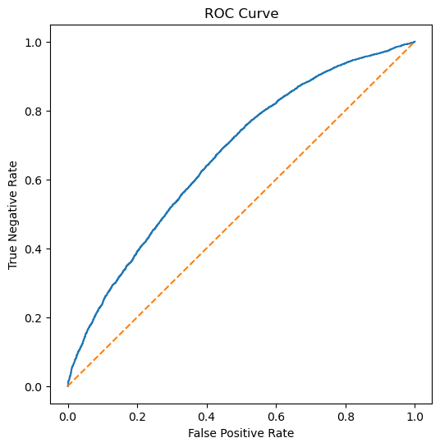
Figure 2. ROC curve for the logistic regression classifier (ROC-AUC = 0.668).

5.3 Statistical Significance (Hypothesis Test Results)
The statsmodels Logit model converged successfully (Pseudo R² = 0.061, Log-Likelihood = -48,166, LLR p-value < 0.001 for the overall model). Coefficients and per-feature significance are shown below:
Feature | Coefficient | Std. Error | z | p-value | Significant (α=0.05)
const (intercept) | -2.2002 | 0.028 | -79.69 | <0.001 | Yes
lead_time | 0.0051 | 0.000 | 50.45 | <0.001 | Yes
adr | 0.0061 | 0.000 | 33.94 | <0.001 | Yes
total_guests | 0.0795 | 0.012 | 6.75 | <0.001 | Yes
total_nights | 0.0174 | 0.003 | 5.13 | <0.001 | Yes
previous_cancellations | 0.5588 | 0.035 | 16.16 | <0.001 | Yes
booking_changes | -0.4975 | 0.015 | -32.14 | <0.001 | Yes
days_in_waiting_list | -0.0020 | 0.001 | -2.70 | 0.007 | Yes
Coefficients are on the log-odds scale. All seven features (plus the intercept) are statistically significant at α = 0.05 — in fact, every p-value is below 0.01.
Decision: Since every feature's p-value is well below 0.05, the null hypothesis is rejected — both overall and for each individual feature. This matches the notebook's programmatic conclusion, which checks whether any p-value falls below 0.05 and prints "Reject the Null Hypothesis."

6. Interpretation of Results

6.1 Direction and Meaning of Effects
- Lead time (+): Longer gaps between booking and arrival are associated with higher cancellation odds — guests who book far ahead have more opportunity to change plans.
- ADR / price (+): Higher average daily rates are associated with higher cancellation odds, consistent with pricier bookings being more sensitive to plan changes.
- Total guests (+) and total nights (+): Larger parties and longer stays are somewhat more likely to be cancelled, plausibly reflecting greater logistical complexity.
- Previous cancellations (+, largest positive effect): Guests with a history of cancelling are considerably more likely to cancel again — past behavior is a strong signal of future behavior.
- Booking changes (−, strongest negative effect): Bookings that have been amended are notably less likely to be cancelled — guests who actively manage their reservation may be more committed to it.
- Days in waiting list (−, small effect): Slightly lower cancellation odds are associated with longer waiting-list time, though the effect size is small.

6.2 Statistical Significance vs. Predictive Power
It is important to distinguish between the two questions this analysis answers. The hypothesis test confirms, with high statistical confidence, that these features are genuinely related to cancellation behavior — this is not due to chance. However, statistical significance does not guarantee strong predictive accuracy, especially in a large dataset (87,203 rows) where even small, practically modest effects can produce very low p-values.
This is exactly what is observed here: the model correctly identifies 97% of bookings that were not cancelled (high recall for class 0), but only 11% of bookings that were actually cancelled (low recall for class 1). This gap is a symptom of class imbalance (27.5% cancelled vs. 72.5% not cancelled) — the model, optimized for overall accuracy, defaults toward predicting the majority class "Not Cancelled" and struggles to flag the minority class "Cancelled."

6.3 Model Fit
The pseudo R² of 0.061 indicates the seven features explain a modest share of the overall variation in cancellation behavior. This is typical for behavioral/human-decision outcomes and does not undermine the hypothesis test — it simply means other unobserved factors (e.g., seasonality, country of origin, deposit type, market segment) also contribute meaningfully to cancellation decisions and were outside the scope of this feature set.

7. Conclusion & Recommendations
The hypothesis test provides strong statistical evidence that lead time, ADR, total guests, total nights, previous cancellations, booking changes, and days in waiting list are all significantly associated with hotel booking cancellations (p < 0.05 for every feature). The null hypothesis is rejected.
The logistic regression model built on these features is a useful explanatory tool but a limited stand-alone predictor of individual cancellations, largely due to class imbalance and the modest overall explanatory power (pseudo R² = 0.061). Recommended next steps:
- Address class imbalance — e.g., class-weighting, oversampling (SMOTE), or adjusting the classification threshold to improve recall on cancelled bookings.
- Expand the feature set — variables such as deposit_type, market_segment, customer_type, and country are available in the dataset and may meaningfully improve predictive performance.
- Try alternative or ensemble models — tree-based methods (Random Forest, Gradient Boosting) often handle imbalanced, non-linear relationships better than logistic regression.
- Operationalize the significant drivers — e.g., proactive outreach for long-lead-time or high-ADR bookings, and closer monitoring of guests with prior cancellation history.

